Natural Language Processing With Sequence Models

Week 1

First, you'll revisit the general structure of neural networks and how they make predictions. I'll show you the structure you'll be using to perform sentiment analysis during this week. Neural networks are computational structures that, in a very simplistic way, attempt to mimic the way the human brain recognizes patterns. They're used in many applications of artificial intelligence and have proven very effective on a variety of tasks, including those in NLP.

Have a look at this example of a simple neural network with n input parameters, two hidden layers, and three output units

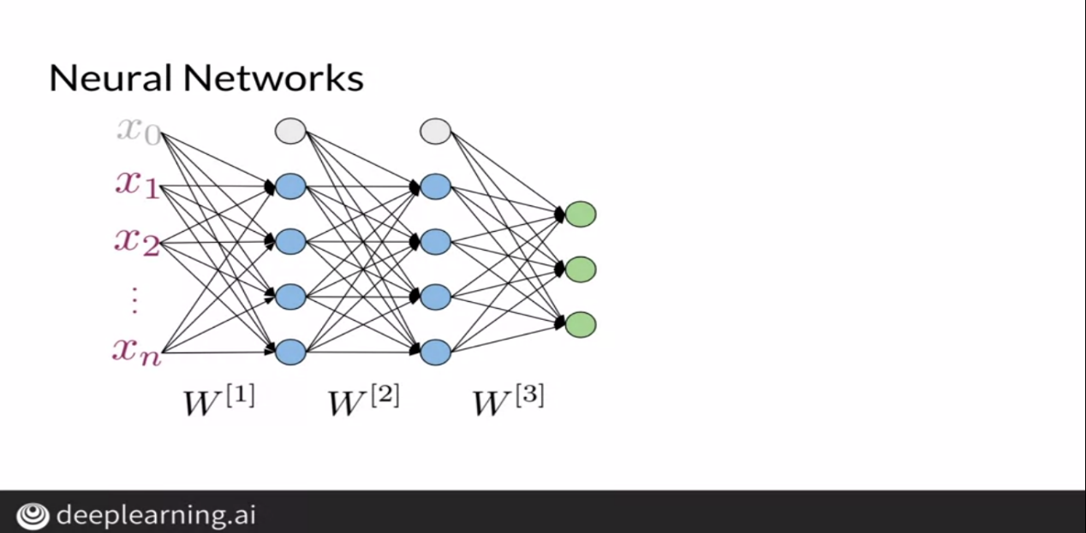

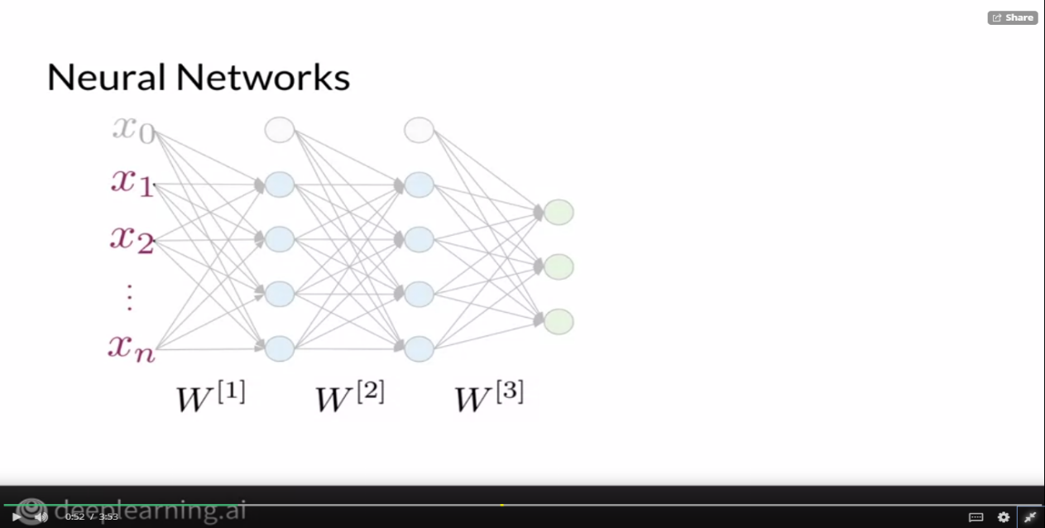

As inputs, this neural network receives a data representation x with n features.

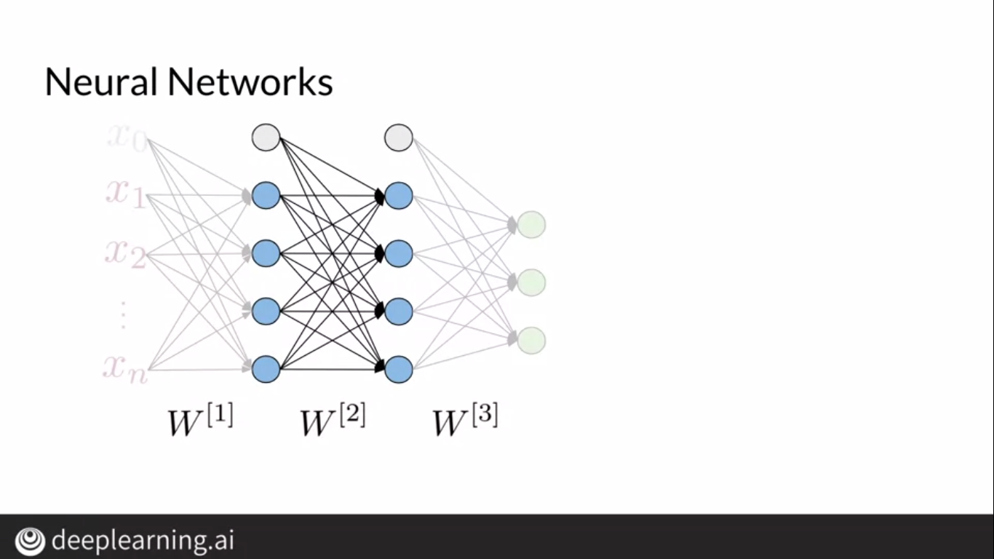

Then performs computations in its hidden layers.

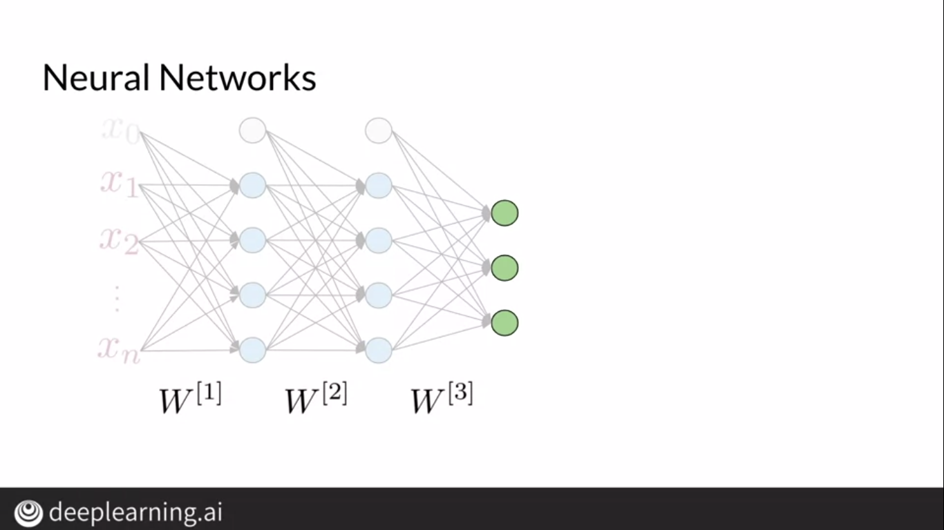

Finally, it delivers an output which in this case has size 3.

